Media release

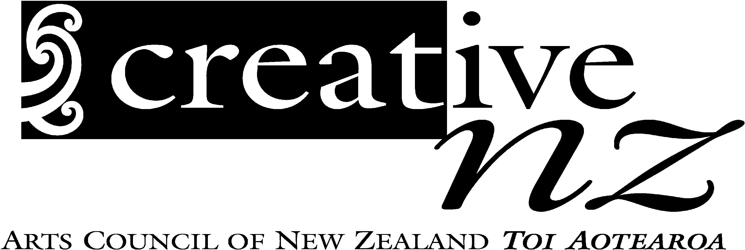

Embargoed until
Saturday 12 August 2006

Te Waka Toi celebrates service to the arts

A devotion to working in their communities and a willingness to pass on their skills and knowledge is a common factor among this year’s recipients of awards from Te Waka Toi, the Māori arts board of Creative New Zealand.

Ngā Taonga Toi a Te Waka Toi – Te Waka Toi Awards are being held in Wellington this evening with seven awards and two scholarships given out.

Te Waka Toi chair Ngahuia Te Awekotuku said recipients showed an unfailing commitment to contributing to the cultural and social well-being of their communities.

“Without exception, the award recipients are individuals who have spent years giving back to their communities,” Professor Te Awekotuku said.

“While we honour them for their commitment to the retention and development of Māori arts and culture, we recognise the benefits that has on communities around the country.

“Our Ta Kingi Ihaka and Te Tohu Aroha mo Ngoi Kumeroa Pewhairangi awards are a recognition of a lifelong contribution to the development and retention of Māori arts and culture. They are kaumatua who within their communities and their artform have worked tirelessly over many years and helped develop what are today thriving and exciting Māori arts.”

The five Ta Kingi Ihaka recipients are:

- Peggy Kaua (Ngāti Porou)
- Rakiihia Tau (Ngai Tahu)
- Sophie Keefe (Ngāti Kahungunu)
- Henare Kingi (Ngā Puhi)
- Rangitihi John Tahuparae (Whanganui)

Te Tohu Aroha mo Ngoi Kumeroa Pewhairangi for contribution to te reo Māori has been awarded posthumously to:

- Te Aopeehi Kara (Tainui, Ngāti Kahungunu)

This year Te Waka Toi has instigated a new award Te Tohu Kē a te Waka Toi. The award will recognise an individual who is making a significant positive difference to the development and retention of Māori arts and culture through their chosen art form.

The inaugural recipient is:
- Robyn Rangihuia Bargh (Te Arawa, Ngāti Awa) for publishing and literature

Te Waka Toi scholarships look towards the future and support two students of Māori artforms who show promise and commitment to both their artform and to Māori development through the arts.

This year’s recipients of Ngā Karahipi a Te Waka Toi/Te Waka Toi Scholarships

- Cameron Webster (Ngā Puhi, Tuhoe)
- Anna-Marie White (Te Ati Awa)

“Previous recipients of this award have gone on to great success as professional artists. These rangatahi all have what it takes to realise their artistic potential and make an impact.This is an investment in the future,” Professor Te Awekotuku said.

Te Tohutiketike at Te Waka Toi – Te Waka Toi’s premiere award, will be presented later in the year to weaver Digeress Te Kanawa,

Ends

Biographical information is attached

For further information contact:
Moerangi Vercoe
Media and Communications Adviser
04 498 0727 or 027 290 1606
moerangiv@creativenz.govt.nz

Photos from the awards ceremony will be available for distribution from early Monday morning

Ngā Taonga Toi a Te Waka Toi
Te Waka Toi Awards
2006

Ngā Tohu a Ta Kingi Ihaka /Sir Kingi Ihaka Awards

Peggy Kaua (Ngāti Porou) of Gisborne has a background includes extensive practice in Māori performing arts and weaving. She learnt weaving during family holidays in Rotorua – helping her family to make dolls for the tourist market. As a young adult she attended the Maori Arts and Crafts School in Wellington under the tutorship of the late Sir Apirana Ngata and was involved in training teachers from Native Schools in the art of taniko. She has worked on Tukutuku panels for several meeting house around the country including Te Hau ki Turanga Meeting House, now in Te Papa. In traditional Māori performing arts she is an expert in Waiata-a-Ringa (action songs) and has been a judge for several competitions. She is an inaugural life member of the Aotearoa Traditional Maori Performing Arts Society.

Rangitihi John Tahuparae (Whanganui, Ngāti Tuwharetoa, Te Arawa, Ngāti Tuwharetoa, Te Arawa, Ngāti Maru Kopiri, Te Atiawa, Ngāti Ruanui, Ngā Rauru, Ngāti Apa Rangitane, Ngāti Maniapoto) of Wanganui is a renowned orator who has provided cultural and tikanga advice to numerous dignitaries, including visiting royalty, through his involvement with Government House and as the first officially appointed kaumatua to Parliament. Closer to his Whanganui home he has run wananga for more than 20 years including an annual river wananga that traces the history of iwi down the Whanganui river.

Sophie Keefe (Ngāti Kahungunu) of Hawke’s Bay has devoted her life to community service, much of it focused around the Raupunga-Mohaka district. She contributed to building the marae Te Mara a Ngata at Kahungunu and Te Huki and Hine-Ringa at Raupunga. She is recognised for her willingness to teach others the traditional knowledge she holds around te reo, food gathering, marae kawa and waiata. Other community involvement includes establishing kohanga reo and a local branch of the Māori women’s welfare league.

Henare Kingi (Nga Puhi) of Wellington is one of the kaumatua of Māori radio. He has worked on Wellington station Te Upoko o te Ika for more than 20 years – still hosting the weekday breakfast show. Around the Wellington region he is recognised as an expert in marae tikanga and whaikorero and was involved in the establishment of the Stokes Valley Marae...

Rakiihia Tau (Ngāi Tuahuriri, Ngāi Tahu) of Tuahiwa has had a lifetime of involvement in promoting all Ngai Tahu culture. In particular, he is recognised as an expert in mahinga kai, traditional food gathering methods, knowledge he gained from growing up at Tuahiwa. He has been chair of the Ngai Tahu Iwi steering group and in 1986 filed the claim to the Waitangi Tribunal on behalf of the Ngāi Tahu Māori Trust Board, which has funded the tribe’s cultural development. More recently he was Chair of the Iwi Steering Group that helped shape Mō Tatou exhibition that opened at Te Papa last month.

Te Tohu Aroha mō Ngoi Kumeroa Pewhairangi

Te Aopehi Kara, (Ngāti Kahungunu and Tainui) of Napier, who died earlier this year aged 77, was a stalwart in the teaching of Māori language. He started his teaching career at age 38 when he retired from shearing and was one of the first in the country to teach Māori language in secondary schools. His interest in the retention of te reo Māori saw him serve on Te Kohanga Reo National Trust and the Film Commission, among a host of community services.

Te Tohu Toi Ke

Robyn Rangihuia Bargh (Te Arawa, Ngāti Awa) of Wellington along with her husband Brian, founded Huia (NZ) Ltd as an independent publishing company in 1991. Robyn had a compelling vision of a New Zealand that valued stories from the people, places and experiences she had grown up with. She envisaged a world of stories and knowledge that would reflect and portray the diversity of experiences of all Māori and their dynamic cultural interface that is an integral part of the evolution of Aotearoa New Zealand. For over 15 years, Huia has successfully taken on this important challenge, exploring the stories and aspirations of these people of Aotearoa New Zealand, creating a mirror for Māori to reflect and interpret their experiences, whilst opening a fascinating window for the rest of the world.

In 1995 Huia initiated the Huia Short Story Awards which has given an opportunity to hundreds of Māori writers to try their hand at writing. A number have been published and some have gone on to win awards. Huia also organise writer workshops to provide opportunities for skill development and networking for Māori writers.

Robyn is also Deputy-chair of Taki Rua Productions which is involved with developing contemporary Māori theatre for New Zealand and the world and Chair of Booksellers New Zealand, the professional association of booksellers and publishers.

Nga Karahipi a te Waka Toi/Te Waka Toi Scholarships

Cameron Webster (Ngā Puhi, Tuhoe) is in the fifth and final year of his degree in Contemporary Māori Visual Arts at Toihoukura in Gisborne. His speciality is clay, an interest he developed while a student at Te Aute College, liking the endless possibilities clay offers as a medium. Cameron has already made a significant contribution to exhibitions around the country, including a solo-exhibition at Tairawhiti Museum last year.

Anna-Marie White (Te Atiawa) has a career path was set in motion from an early age with her Dad a long time adviser to the Taranaki Museum (now Puke Ariki) and her Mum, an accomplished weaver. But while Anna-Marie does produce art work herself – painting, printmaking, weaving - she’s tailored her studies towards a career in curatorial and collection management, particularly of taonga Māori. Already she boasts an impressive CV that belies her 28 years – including as a curator at Puke Ariki in her home town of New Plymouth and now at Nelson’s Suter Gallery.

